BOOK ORDER INFORMATION
The Message of the Animal King: Poems for Kids to Laugh and Learn
by Rosie Pova
ISBN #1-4120-4732-3
www.Trafford.com or Call: 1-888-232-4444

Ladybug and Caterpillar: The Way to Friendship by Rosie Pova
ISBN #1-60474-950-4
www.PublishAmerica.net

The Animal King’s Words of Wisdom by Rosie Pova, Illustrated by Mincho Petkov
ISBN # 978-1-4489-9839-5
www.PublishAmerica.net
……………………………………………………………………………………………………………………………………………………………………………………………………………………………….
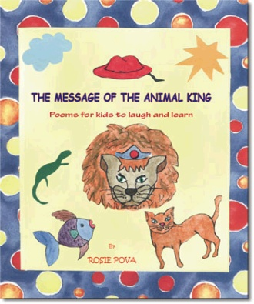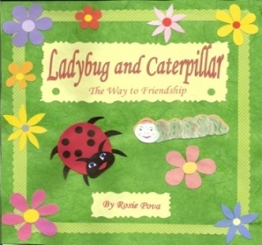
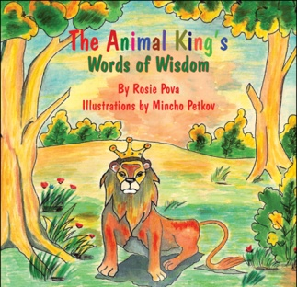
*Other online sources: www.Amazon.com ; www.bn.com

