Meet the Author!
Story Time FUN-tastic

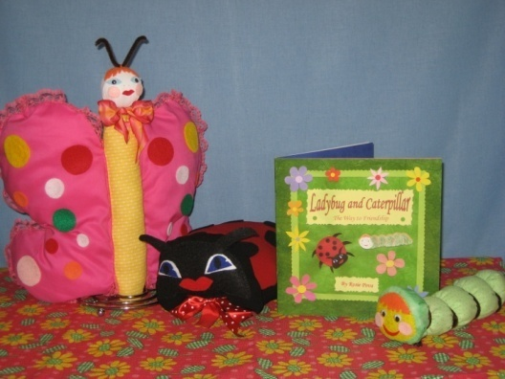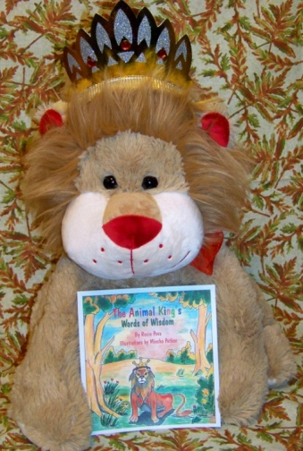
●Ladybug and Caterpillar: The Way to Friendship● ●The Animal King’s Words of Wisdom ●
-------------------------------------------------------------------------------------------------------------------------------------------------------------------------
Book reading with fun games and activities to follow along, arts & crafts, music, puppets, and more! Kids will love this interactive story time. Plus, a goody bag for each child.
* * *
Children’s author Rosie Pova reads her picture books in this interactive story time filled with games, activities, arts & crafts, music and more in a fun a warm environment. Reinforce the love for reading, instill traditional values, provoke imagination, promote creativity and develop social skills through participation and sharing, blended with fun, humor and educational elements. This story time will create lasting memories for your child. Let’s share a story!

Age 3-6Yrs.
Instructor: Rosie Pova

*Classes are offered at Gale Fields and Holford Recreation Centers in Garland, and Florence Recreation Center in Mesquite, Texas.
Contact your local center for more information and availability. Space is limited, call today to enroll.

www.rosiepovapicturebooks.weebly.com

